Coffee Business
The Vistabean coffee chain is distributed across the different states in the US. Most of the stores are major market and the concentration of the stores varies across the states. For instance, they are densely populated in the states of Texas, California and Ohio and moderately distributed in Utah and New Mexico among others.
Figure 1; Geographical spread of the coffee chain stores
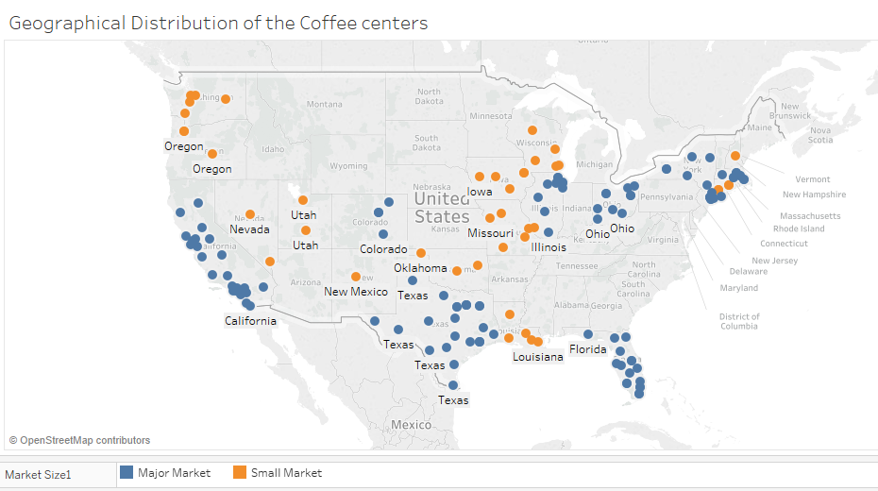
Product portfolio
The Coffee chain portfolio has four product types: Coffee, Tea, Espresso and Herbal Tea. There are further two categories which are Beans and Leaves. The Beans category is comprised of Coffee and Empress while Tea and Herbal Tea fall at the Leaves category. Breaking the pact further indicates that the chain offers 13 products depending on the different variety from the four product types.
Figure 2: Product Portfolio
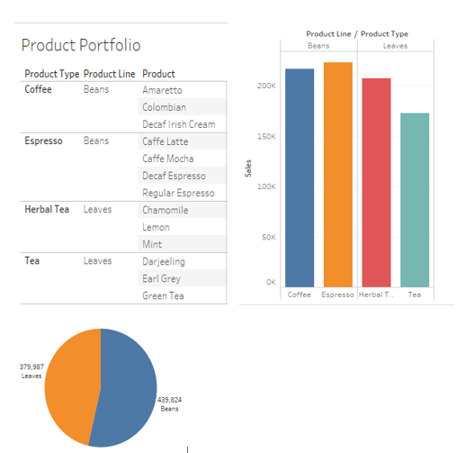

Considering the overall sales according to the product line, Beans have a higher percentage of the market share compared to the leaves. For the beans, Espresso made higher sales than Coffee while for the Leaves, Herbal tea sales were higher than that of Tea.
Product Sales
The products performed differently at the market. The following is a first glance of the different performances that would help identify the underperforming items.
Figure 3; product sales
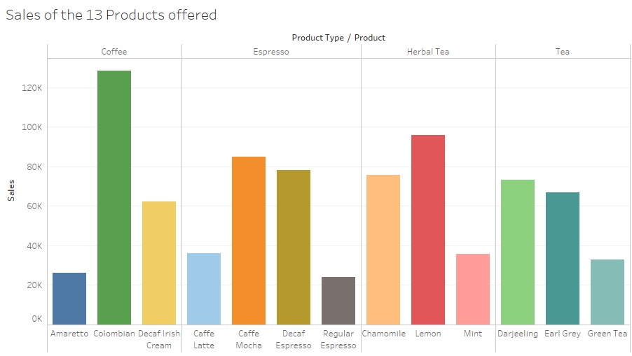
From the Figure 3 above, the underperforming items out of the 13 offered by the chain were Amaretto under Coffee category, Regular Espresso and Caffe Latte under Espresso, Mint under Herbal Tea and Green Tea under Tea category. However, further analysis is needed to establish if the items with the lowest profit and determine if they are the same that recorded low sales. Deriving from Figure 4 below, the four items listed above that made the lowest sales still made the lowest profits with an addition of Decaf Espresso under the Espresso category that also recorded low profits despite the high sales.
Figure 4
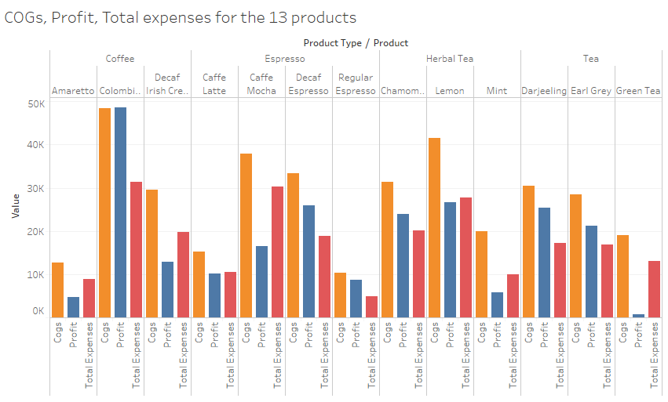
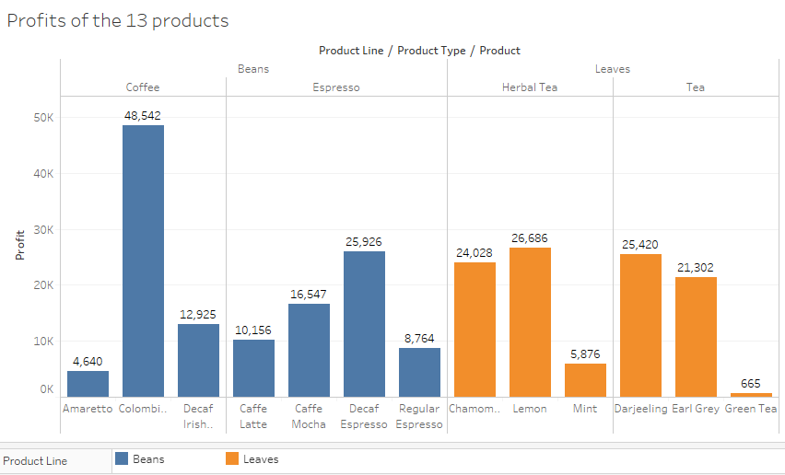
Company Strategy
Vistabean should consider reviewing its products based on the profits they generate instead of the quantities sold. Based on the analysis above, Espresso was the most affected where despite making relatively similar sales with Tea, the profits were less. It is therefore important for the company to review the products and identify those making loss or insignificant profits compared to the sales made. Such products should be eliminated from the process but the process should consider regional parity and elimination be conducted on areas generating losses.
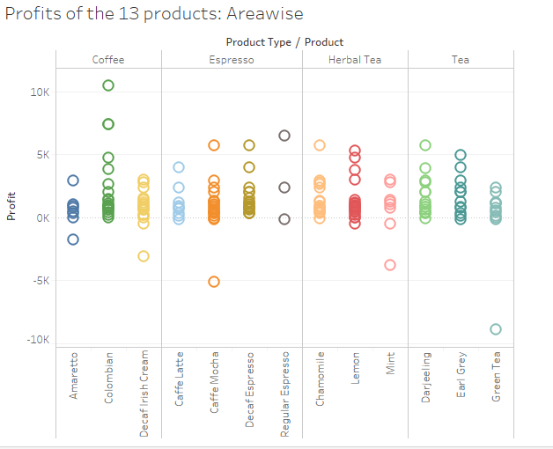

Conclusion and recommendations
The consumption of Beans and Leaves products varies depending on the season. For instance, Beans are on demand during autumn. Therefore, in the review on the elimination of some products, the season element should be considered and maybe supply of the underperforming products should be confined during peak seasons.
The item that should be reviewed are Amaretto, Regular Espresso, Caffe Latte, Mint, Green Tea and Decaf Espresso with much attention to Green Tea which should be red zoned given the high marketing spends allocated in it and the low returns. Overall, the company should minimize its marketing spending by seeking alternative ways requiring minimal spending.
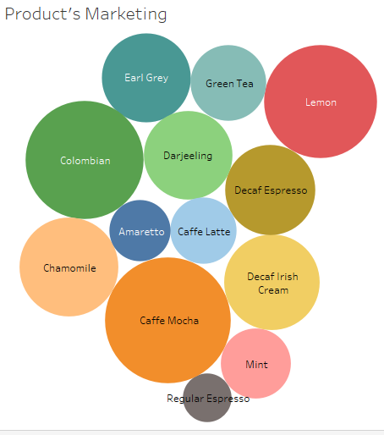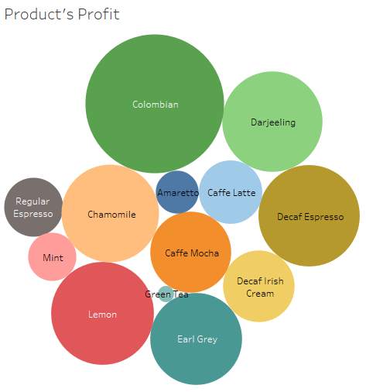
From the analysis, the company should review the following items in the specified areas, among others
Amaretto in California and Oregon
Decaf Irish Cream in California and New Mexico
Caffe Latte in New Mexico and Louisiana
Caffe Mocha in New York, Massachusetts and Connecticut
Regular Espresso in New Hampshire
Mint Herbal Tea in Utah and New York
Green Tea in Utah, Nevada and Missouri
In conclusion, whenever possible, the company should ensure product promotion for the underperforming products. Otherwise, the products should be cut off from the affected areas and instead reverted to the performing regions.

